

Practices for Secure Software Report

Table of Contents
Document Revision History 3
Client 3
Instructions 3
Developer 4
1. Algorithm Cipher 4
2. Certificate Generation 4
3. Deploy Cipher 4
4. Secure Communications 4
5. Secondary Testing 4
6. Functional Testing 4
7. Summary 4
8. Industry Standard Best Practices 4

Document Revision History

Version | Date | Author | Comments
1.0 | 17 Oct 2026 | Deandre Jackson

Client



Instructions

Submit this completed practices for secure software report. Replace the bracketed text with the relevant information. You must document your process for writing secure communications and refactoring code that complies with software security testing protocols.

- Respond to the steps outlined below and include your findings.
- Respond using your own words. You may also choose to include images or supporting materials. If you include them, make certain to insert them in all the relevant locations in the document.
- Refer to the Project Two Guidelines and Rubric for more detailed instructions about each section of the template.

Developer
Deandre Jackson

Algorithm Cipher

The algorithm cipher recommended is the SHA-256 (Secure Hash Algorithm) which is a cryptographic hash developed by the NSA and published by NIST in 2001. It converts any input data into a fixed 256-bit output represented as a 64-character hexadecimal string.

The SHA-256 Cryptographic hash is designed to go beyond simple error detection and are built to actively defend against intentional data manipulation using the “Avalanche Effect” which causes more than half of the hash output to change when even a single bit changes. The same input will produce the same hash, but a different input produces a drastically different output no matter how small the change is. This means it is safe against attacks that use two inputs to produce the same hash. It is computationally infeasible to reverse the hash, and the data will remain secure.

Avoiding collisions in hashing algorithms means distinct inputs cannot produce the same hashed output. Since the outputs are of a fixed size, if two different inputs can produce the same hashed output, a malicious actor can send corrupt or dangerous files with the expected checksum for a legitimate file to an unsuspecting user. There would be no way to know for sure that the file they downloaded or received was the one they expected. This ensures data integrity and security between the source of data and the receiver of the data.

Certificate Generation
Insert a screenshot below of the CER file.

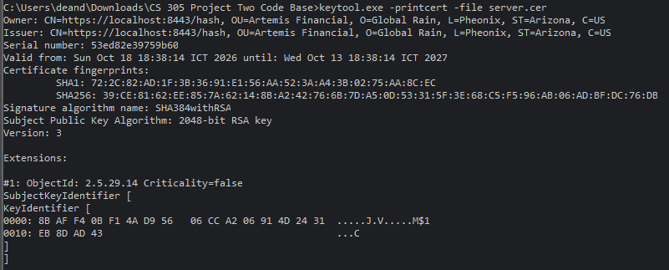

Deploy Cipher
Insert a screenshot below of the checksum verification.
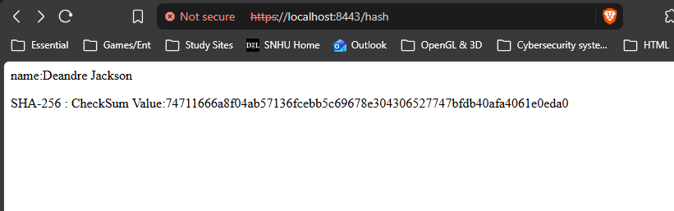

Secure Communications
Insert a screenshot below of the web browser that shows a secure webpage.

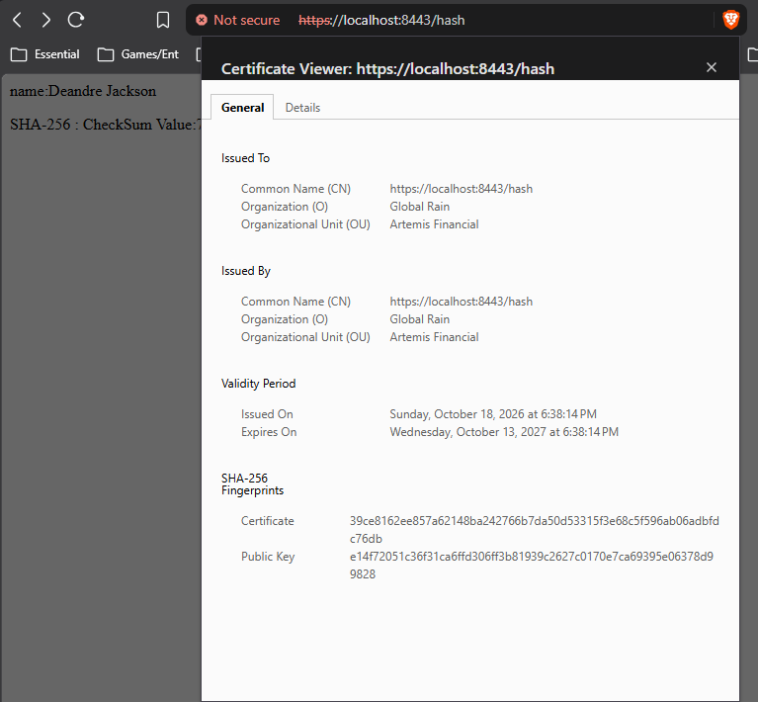

Secondary Testing
Insert screenshots below of the refactored code executed without errors and the dependency-check report.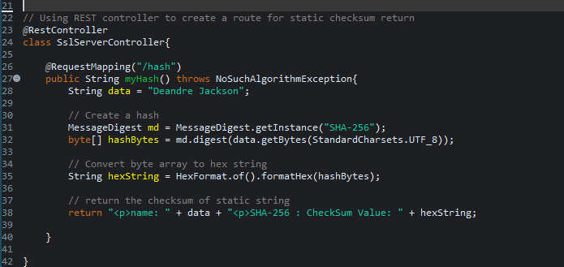 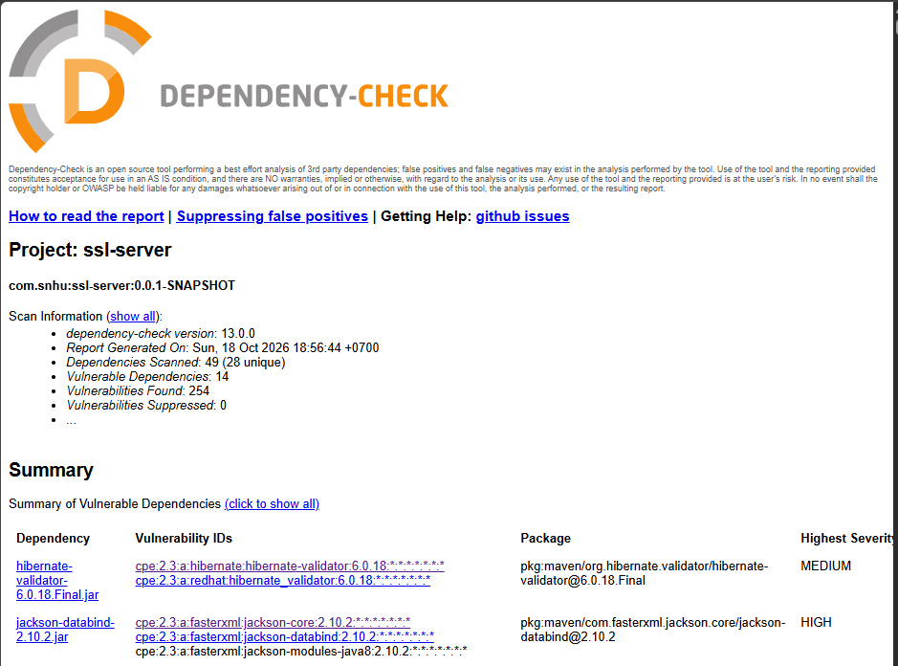

Functional Testing
Insert a screenshot below of the refactored code executed without errors.
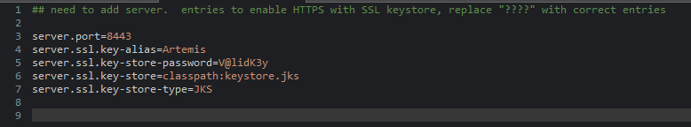
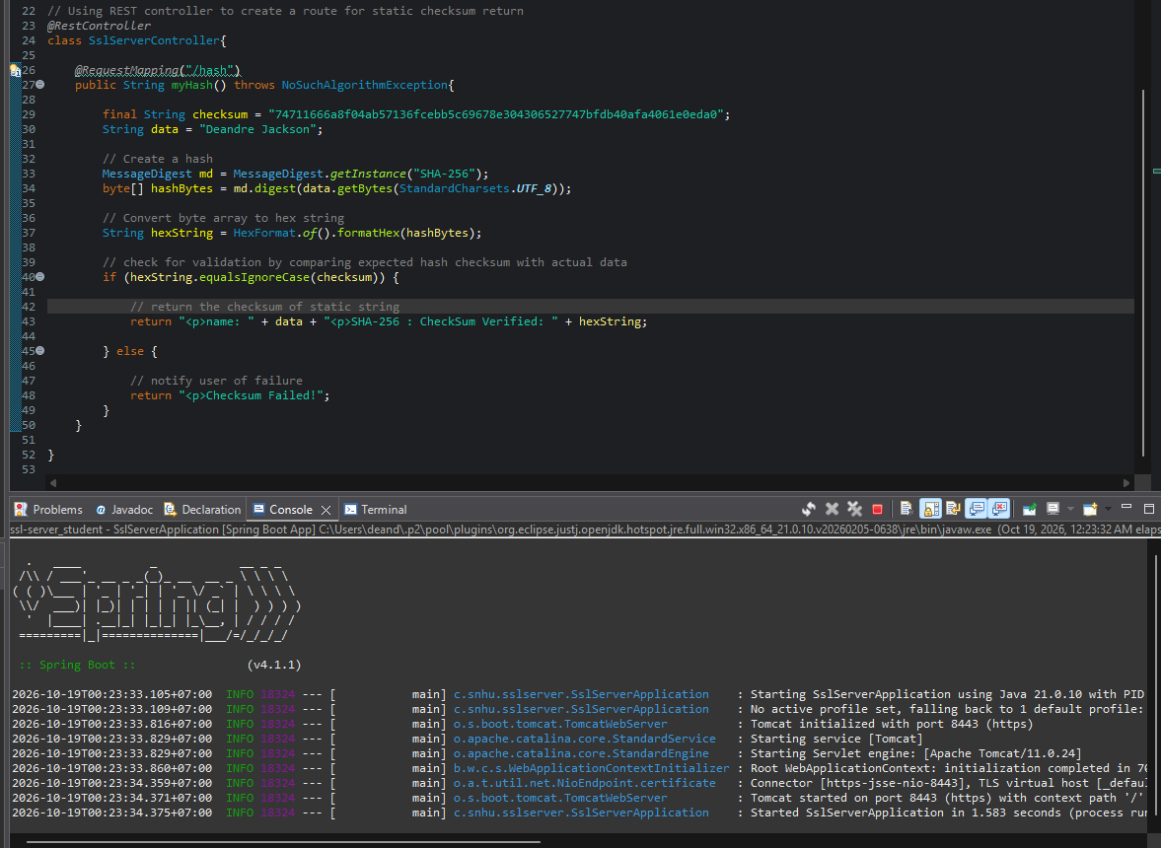

Summary

The web application for Artemis Financial has been refactored to implement the SHA-256 cryptographic hash algorithm to ensure data integrity by checksum verification. It additionally enforces HTTPS connections for secure communication using a self-signed certificate created with the Java Keytool. The certificate encrypts the transmitted data to protect it from malicious actors, which addresses critical vulnerabilities in the web application when handling client-server connections. The self-signed certificate is for development and will be replaced with an official CA trusted certificate for launch.

The code complies with testing protocols by using the automated OWASP Dependency-Check Maven tool, which allowed us to verify that there were no new vulnerabilities once the code was refactored. Upon manual review, no further syntactical or logical errors were found and testing showed that the code functions as intended.

Industry Standard Best Practices

According to industry standards, HTTPS and TLS are the primary mechanisms for securing transmitted data and protecting it from interception or tampering by mandating communication between clients and servers follows the trusted protocol. Checksum validation and cryptographic signatures are essential for ensuring that the client-server data transfers are verified and legitimate to ensure trust and mitigate middle-man or injection attacks by impersonating trusted sources. These practices focus on the most important and vulnerable points of exploitation in our clients web application. By adding these layers of security, the application will be extensively protected against expected threats.

As a financial advisement company, Artemis Financial’s success depends on their ability to build trust with their clients as those clients will be seeking advice, security, risk assessment, and plans to create wealth through the services offered at the company. As a financial advisement organization, Artemis Financial will be an attractive target since they will have information that can be leveraged for a quick payout to maintain company trust with clients. Our client will need secure communications to protect against these threats as they will be liable for losses incurred by those clients if they fail to protect their data. As such, the industry standards are the best insurance for our client.

